**INTRODUCTION TO ARTIFICIAL INTELLIGENCE**

**INTRODUCTION**

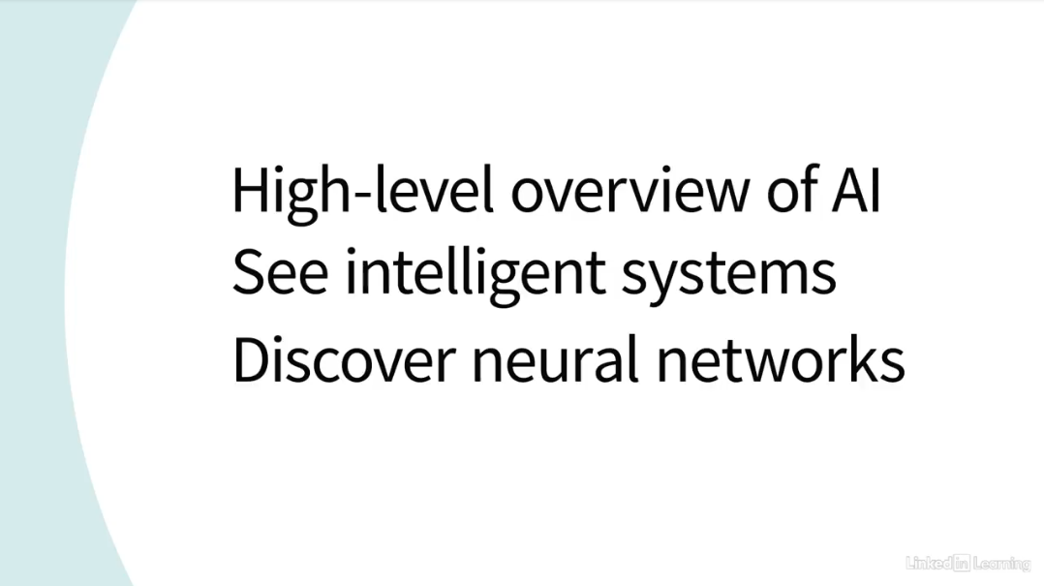

1. **WHAT IS ARTIFICIAL INTELLIGENCE?**

**DEFINE GENERAL INTELLIGENCE**

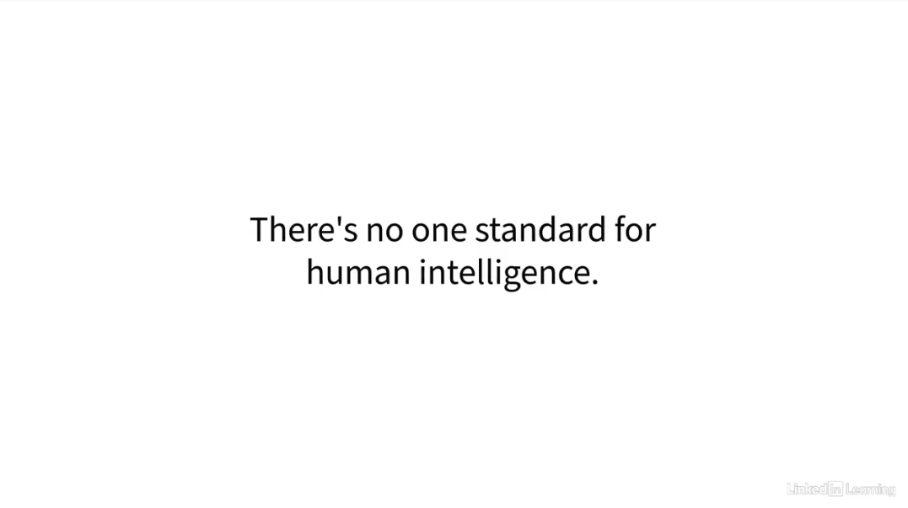

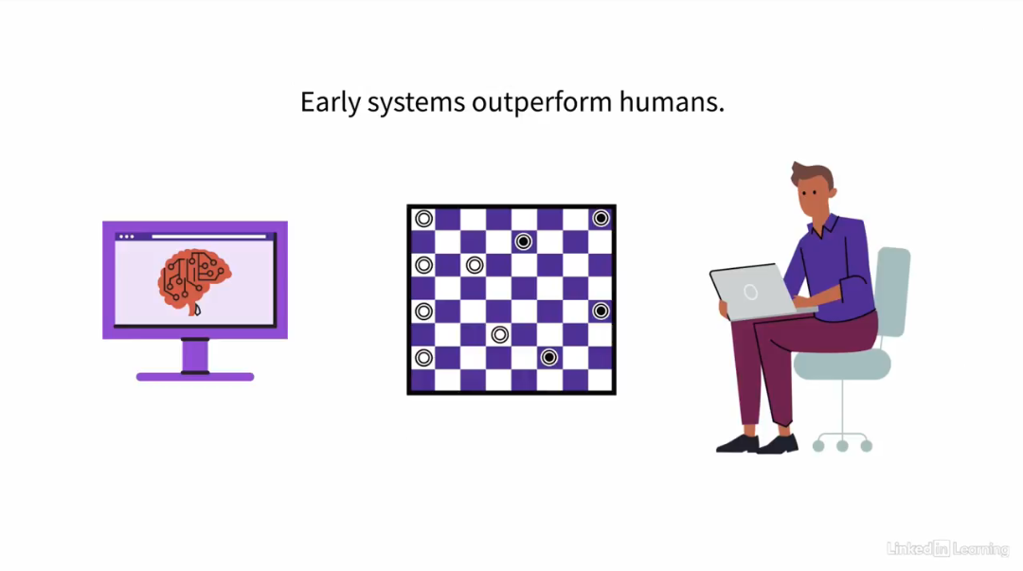

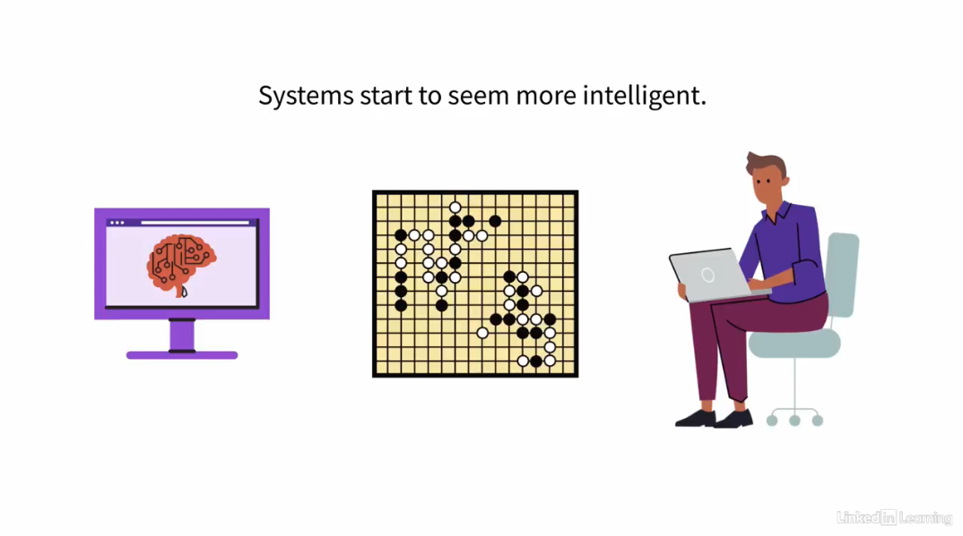

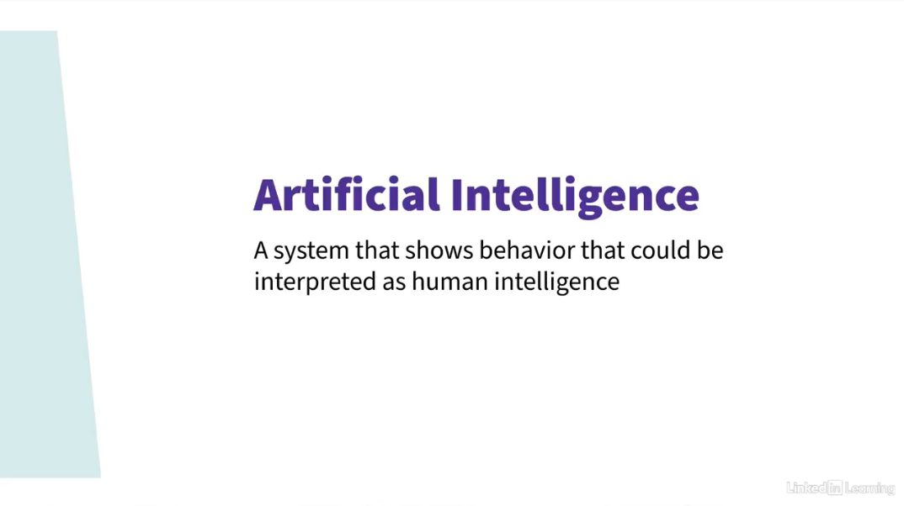

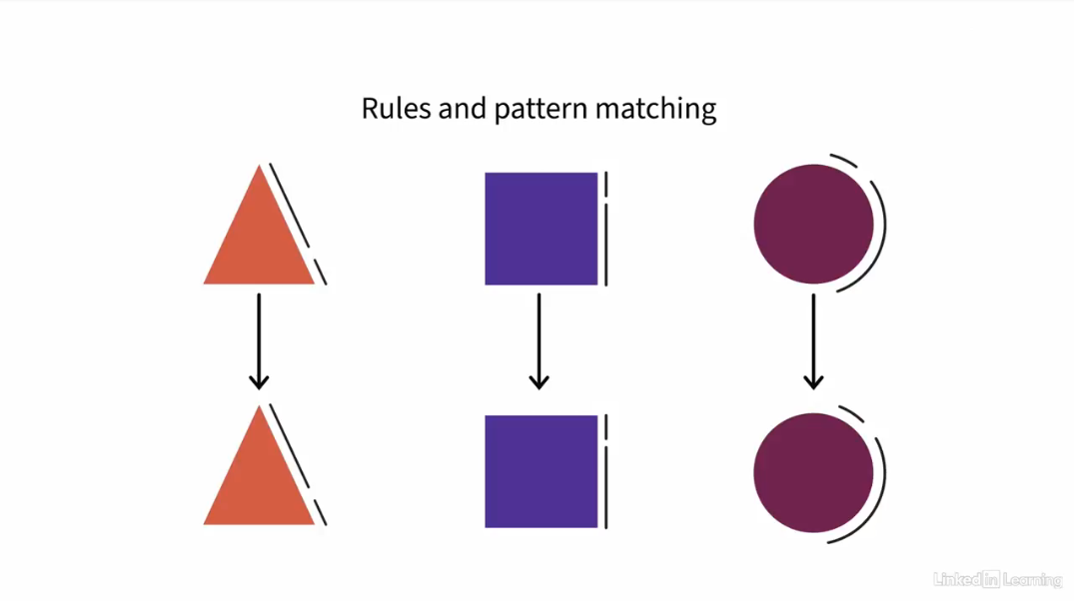

**THE GENERAL PROBLEM SOLVER**

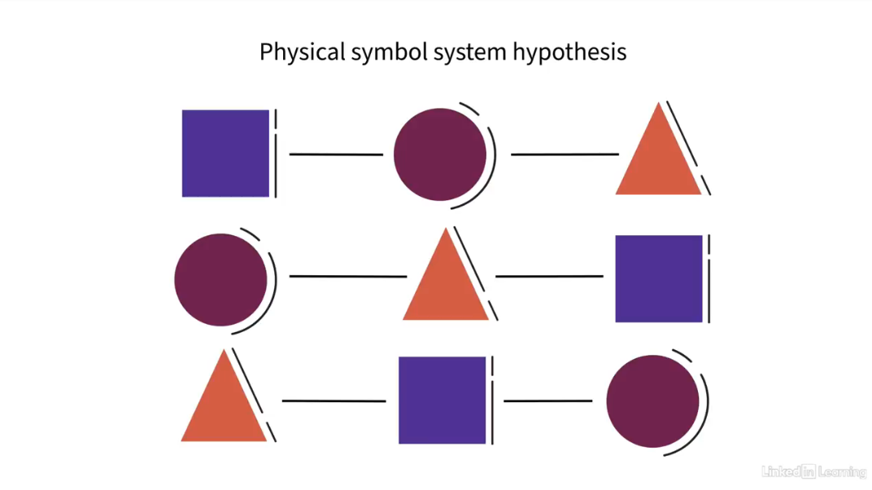

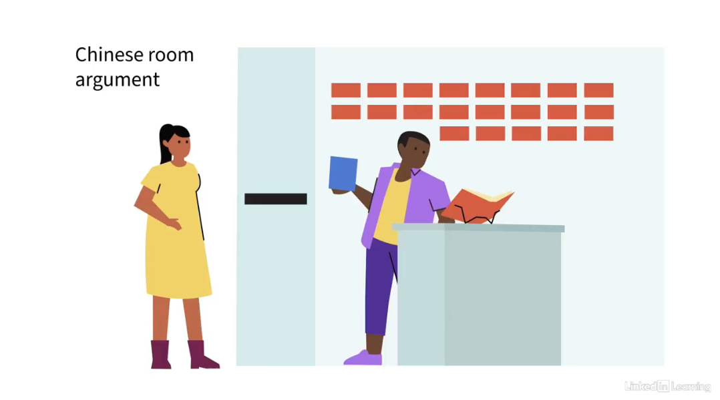

**STRONG VS. WEAK AI**

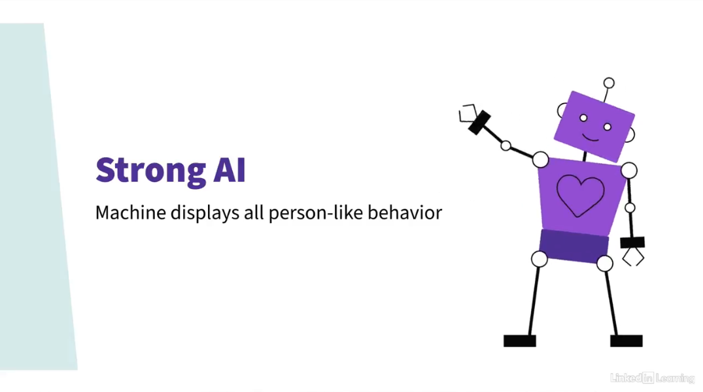

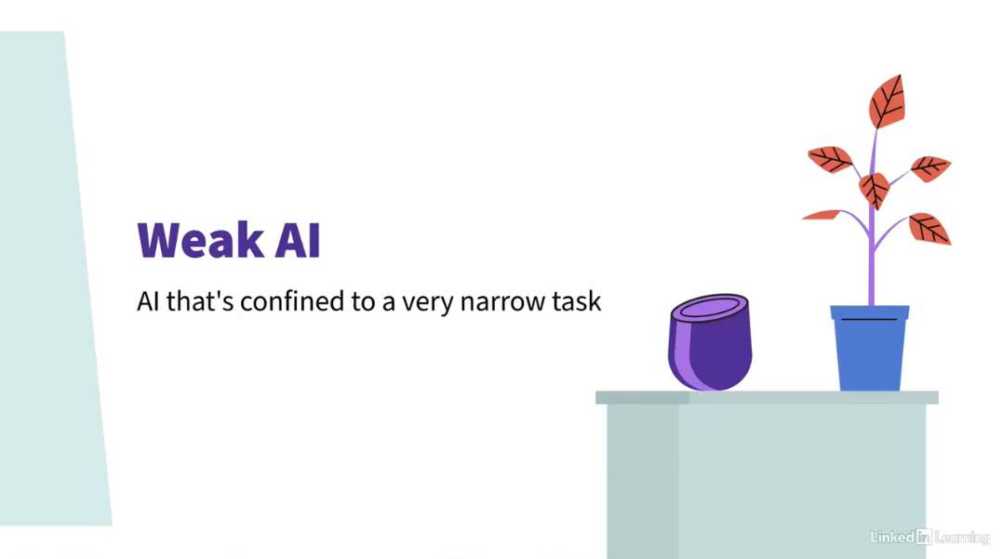

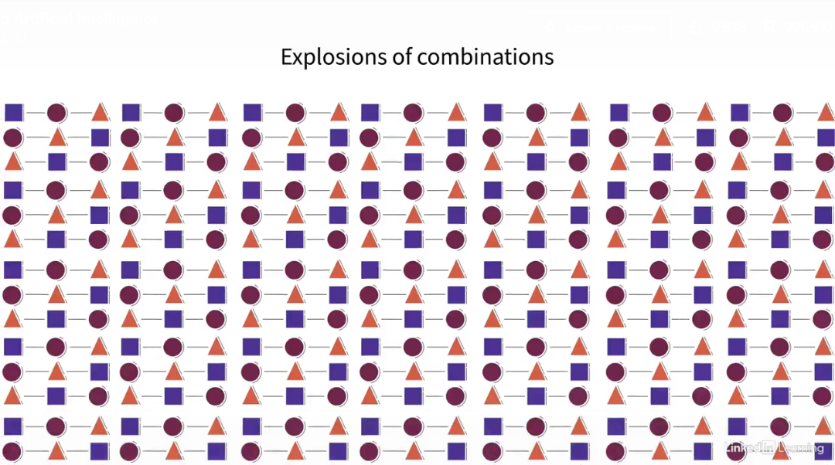

1. **THE RISE OF MACHINE LEARNING**

**MACHINE LEARNING**